PowerPoint On Your Local Computer

- Open the Microsoft PowerPoint application on your computer.
- Go to File > New from Template.
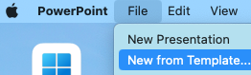
- You will see folders in the section “Minnesota State”. Double click on the MHD-Employees or MHD-Students, respectively, folder to open it.
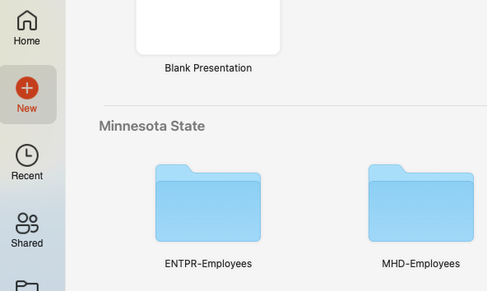

- In the MHD-Employees folder, you will see seven MSUM-branded PowerPoint slides that you can use. The file named “MSUM-All-Options-Presentation” includes all slide layouts. Click on the presentation you would like to use and then click on the dark orange “Create” button on the bottom right.
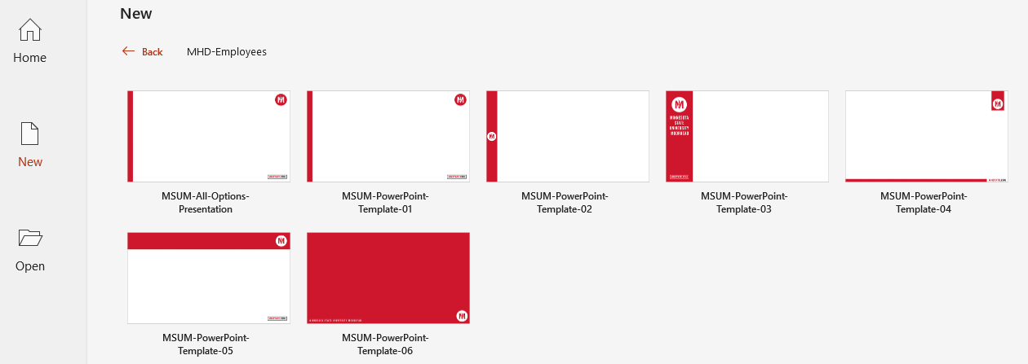
- Once your PowerPoint file has been started, you can add more branded template slides to it by clicking on New Slide>Duplicate Slide or New Slide>Re-use Slides.
