PowerPoint on Office 365

- Open Microsoft PowerPoint application in Office365.
- You should see on the screen a folder called “OfficeTemplates”, click on the folder called “OfficeTemplates”.
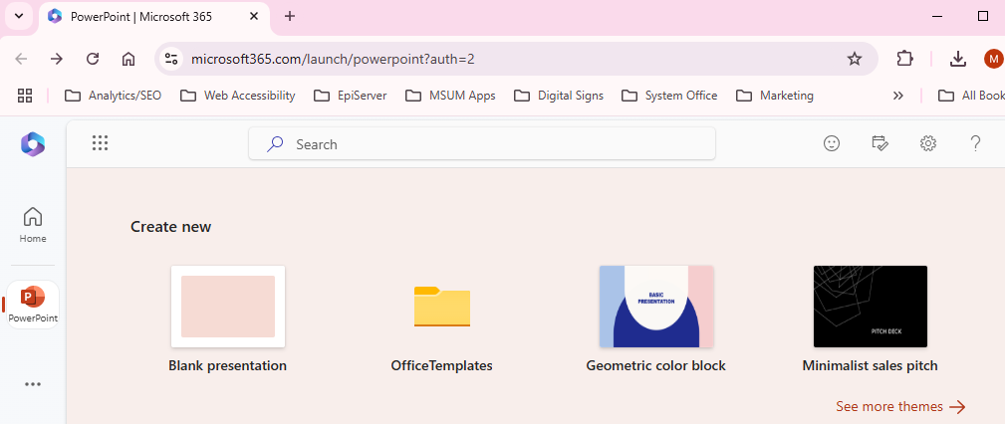
- After you click on the folder titled “OfficeTemplates”, you should have an option that says, “Minnesota State”. Click on “Minnesota State” to expand the options.
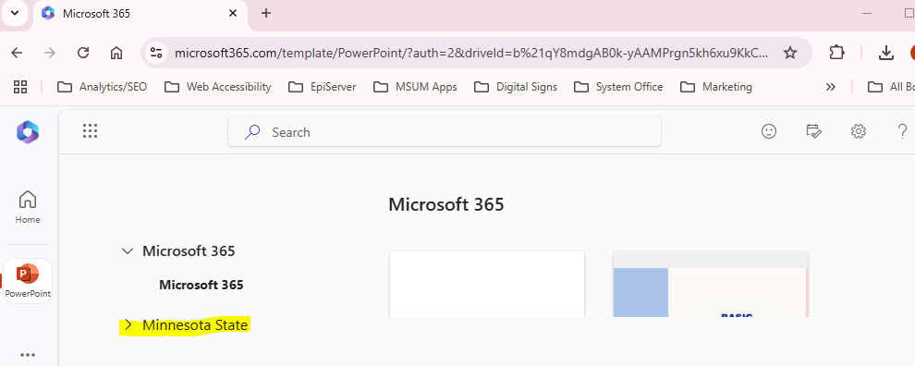
See next page.

- You will then see an option for “MHD-Employees” or “MHD-Students,” depending on who you are and your access level. If you are an employee, click on the “MHD-Employees”; if you are a student click on the “MHD-Students”.
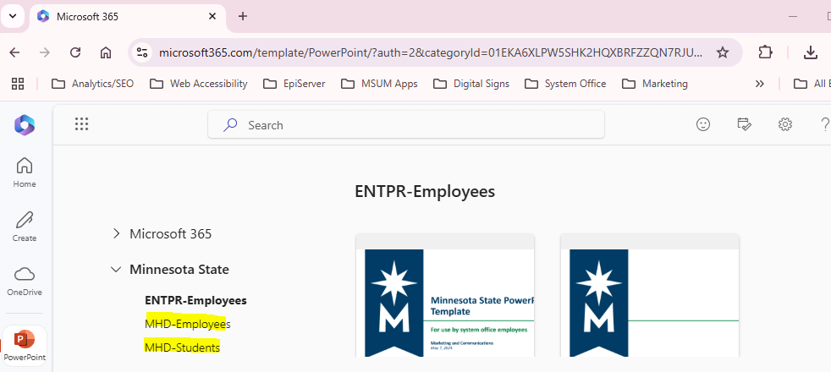
- You will then see seven MSUM branded PowerPoint slides. The file named “MSUM-All-Options-Presentation” includes ALL six slide layouts in one file.
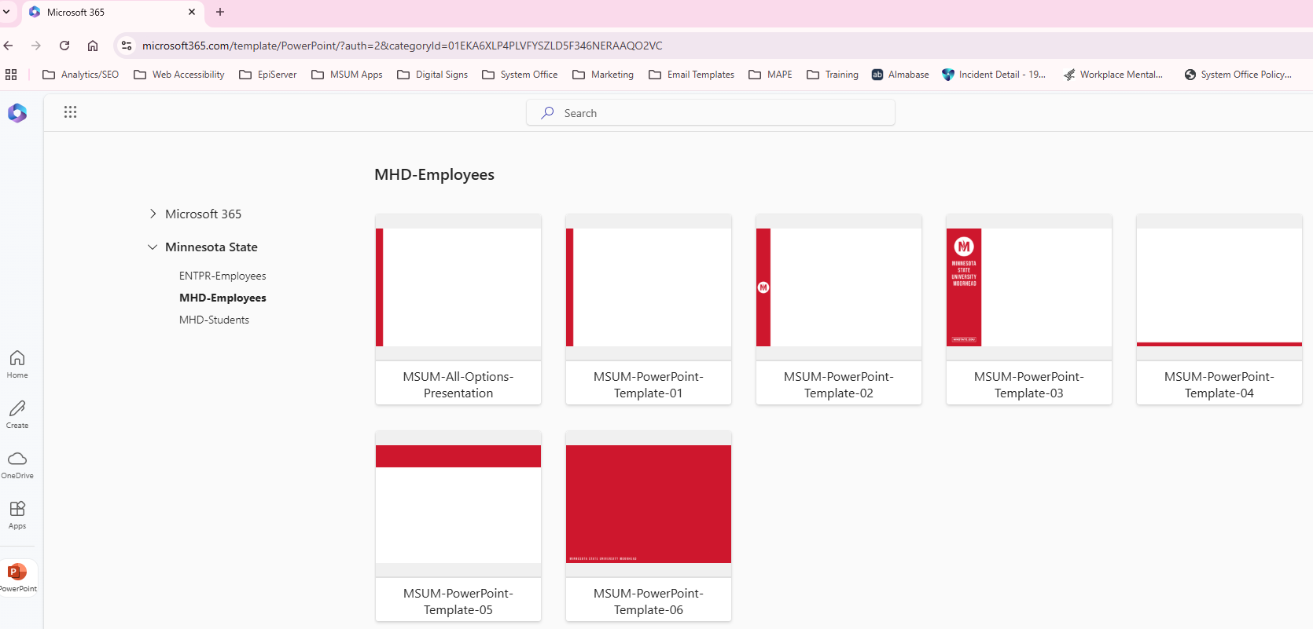
See next page.

- If you hover over each option, you can either click “Create” or “Preview”. If you want a better view of what the template looks like, click “Preview”. Otherwise click “Create” on the template you would like to use.
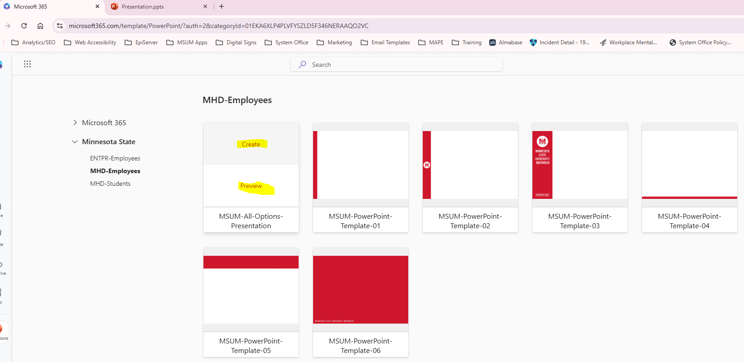
- Once your PowerPoint file has been started, you can add more branded template slides to it by clicking on New Slide. (See visual on next page.)
